AIDD 30-Day Challenge — Task 2
Student Name: Muskan Atiq
Roll Number: 156934
Instructor: Sir Hamzah Syed
Class Slot: Friday — 6:00 PM to 9:00 PM

Theory (Short Questions)

1. Nine Pillars Understanding:
Q1: Why is using AI Development Agents (like Gemini CLI) for repetitive setup tasks better for your growth as a system architect?
Using AI Development Agents for repetitive tasks saves time and mental effort. Instead of wasting energy on basic setup, configuration, or boilerplate code, I can focus on higher-level thinking such as system design, architecture planning, and decision-making. This trains my mind to think like a system architect, not just a coder. Over time, it improves my understanding of the big picture and makes me more focused on structure, scalability, and efficiency.
Q2: Explain how the Nine Pillars of AIDD help a developer grow into an M-Shaped Developer.
The Nine Pillars of AIDD combine multiple approaches such as Test-Driven Development, Specification-Driven Development, AI CLI tools, agents, and system thinking. These pillars allow a developer to work across multiple domains like design, architecture, AI tooling, testing, and automation. This creates deep skills in more than one area, which is the main quality of an M-Shaped Developer — someone who has expertise in multiple related fields instead of only one.

2. Vibe Coding vs Specification-Driven Development:
Q1: Why does Vibe Coding usually create problems after one week?
Vibe Coding is based on feelings and intuition without a clear plan. The developer starts coding without documented requirements, structure, or design. After a few days, the code becomes messy, confusing, and hard to update or fix. There is no clear purpose, structure, or future plan, which creates problems during expansion, debugging, and teamwork.
Q2: How would Specification-Driven Development prevent those problems?
Specification-Driven Development (SDD) requires writing clear and detailed specifications before coding begins. This gives the project a clear direction, purpose, and structure. Every part of the system is planned first, so confusion is reduced, code is organized, and improvements can be made easily even after a long time. It also makes teamwork smoother because everyone understands the requirements.

3. Architecture Thinking:
Q1: How does architecture-first thinking change the role of a developer in AIDD?
Architecture-first thinking transforms the developer from a simple coder into a system designer. Instead of thinking about only writing code, the developer now thinks about how all parts of the system will work together. This includes performance, scalability, security, and future expansion. The developer becomes a planner, strategist, and decision-maker.
Q2: Why must developers think in layers and systems instead of raw code?
Modern applications are complex and connected. If a developer only focuses on raw code, they miss the full system view. Thinking in layers (models, logic, interface, agents, etc.) helps create well-structured, clean, and maintainable systems. It also allows easy debugging, testing, and scaling in the future.

Part B (Practical Task)

1. Gemini CLI Prompt:
Generate a concise 1-paragraph technical specification for an email validation function.
The function must verify the presence of the '@' symbol, ensure a valid domain extension such as .com or .org,
and return specific, user-friendly error messages when validation fails.

2. Paragraph Specification:
Email validation function validateEmail(email: string): ValidationResult will rigorously check an input string for
adherence to standard email format. It will confirm the presence of a single '@' symbol, which must not be at the start or
end of the string, and contain at least one character before and after it. Furthermore, it will verify that the domain
part contains a valid top-level domain (TLD) from a predefined list (e.g., .com, .org, .net, .edu, etc.), ensuring the TLD
is at least two characters long and follows a period. Upon failure, it will return a ValidationResult object containing a
boolean isValid and a localized, user-friendly errorMessage string detailing the specific validation rule that was
violated (e.g., "Email is missing an '@' symbol," "Invalid domain extension," or "Email format is incorrect").

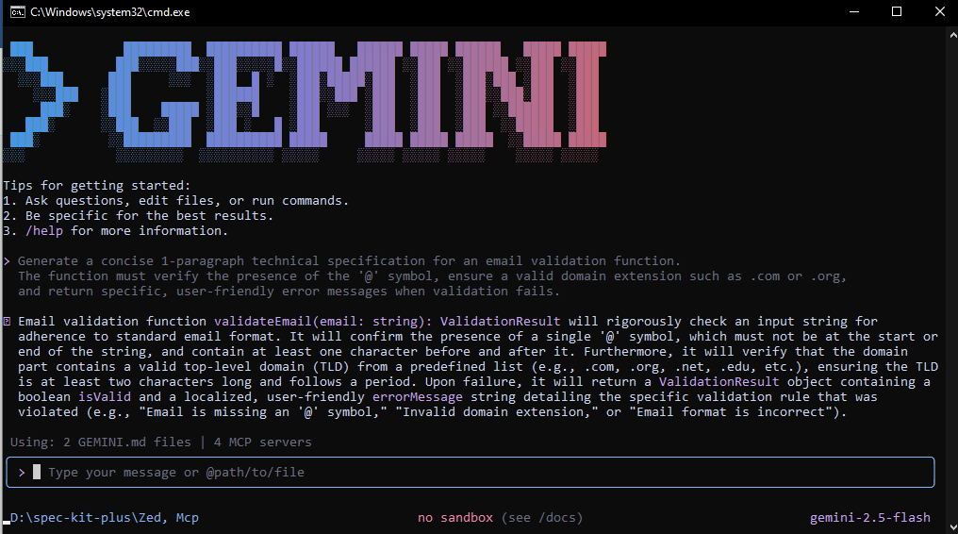

Self-Test (MCQs)
1. What is the main purpose of Spec-Driven Development?

A. Make coding faster
B. Clear requirements before coding begins
C. Remove developers
D. Avoid documentation
Answer: b) Clear requirements before coding begins

2. What is the biggest mindset shift in AI-Driven Development?

A. Writing more code manually
B. Thinking in systems and clear instructions
C. Memorizing more syntax
D. Working without any tools
Answer: b) Thinking in systems and clear instructions

3. Biggest failure of Vibe Coding?

A. AI stops responding
B. Architecture becomes hard to extend
C. Code runs slow
D. Fewer comments written
Answer: b) Architecture becomes hard to extend

4. Main advantage of using AI CLI agents (like Gemini CLI)?

A. They replace the developer completely
B. Handle repetitive tasks so dev focuses on design & problem-solving
C. Make coding faster but less reliable
D. Make coding optional
Answer: b) Handle repetitive tasks so dev focuses on design & problem-solving

5. What defines an M-Shaped Developer?

A. Knows little about everything
B. Deep in only one field
C. Deep skills in multiple related domains
D. Works without AI tools
Answer: c) Deep skills in multiple related domains

